34.25: 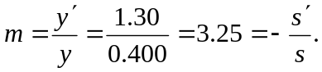 Also:
(to the left).
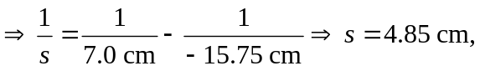and the image is virtual 